COLORADO STATE UNIVERSITY

ANTENNA TEST RANGE

OPERATION MANUAL

Table of Contents

**Section I - Getting Started** **2**

**Section II - Overview** **4**

Motors and Axes 4

Network Analyzer 9

Graphical User Interface 9

Scanning Modes 10

Arduino and Motor Controller 11

**Section III - Software Operation** **1**2

Graphics User Interface (GUI) Overview 12

Saving and Loading Settings 12

Managing Events 13

Controlling Motor Movement 14

Interfacing with the Network Analyzer 17

Generating Scans 18

Managing Data 19

Plotting Data With GUI 20

Plotting Data With MATLAB 22

**Section IV - Network Analyzer Operation** **2**4

**Section V - Motor Controller and Arduino Guide** **2**7

**Section VI - Common Errors and Troubleshooting** **3**0

PNA 30

GUI 31

Arduino / Controller 32

**Section VII - Future Tasks** **3**3

# **Section I - Getting Started**

1. Make sure you have access to the B111 lab inside the engineering building.
   1. Contact Oliveria Notaros [Olivera@colostate.edu]
2. The first step in getting access to the range is downloading all files from the software tab of the google drive (contact previous team if access is not already established).
   1. Look inside Software → CSUATR Program → New Users
   2. Download all these files to a location of your choice
3. Install IOLibSuite_18_1_25310.exe with default settings, and restart your computer
4. Download the latest version of the arduino software in Software → Arduino Program, and load it onto the arduino in the B111 lab using Arduino Sketchbook
   1. To do this, open the file in Sketchbook, and perform the following
      1. Tools → Board and select "Arduino/Genuino Mega or Mega 2560"
      2. Go to Tools → Processor and select "ATmega2560"
      3. Go to Tools → Programmer and select "Arduino Gemma"
      4. Select ‘Upload’ on main banner
5. Copy the executable and the dlls into a separate folder together
   1. The folder should contain the following:
      1. *CSUATR.exe*
      2. *OxyPlot.dll*
      3. *OxyPlot.WindowsForms.dll*
      4. *Ivi.Visa.dll*
      5. *AgN99xx_NA_A_06_23.dll*
      6. *System.ValueTuple.dll*
   2. In this folder, run the executable
   3. Two folders will be created
      1. *Meta* - Contains directory for program settings and data
      2. *Settings* - Contains autofill data for program GUI
6. Make sure that the power supply is plugged into a power brick, and flip the switch to turn on
   1. It is recommended that, unless otherwise resolved, to always check for short circuits on the arduino before turning on power.
7. From the ‘Connections’ tab, select ‘Re-scan Ports’, then from the controller drop-down menu, select the available port and attempt to connect. If this does not work, ensure that the Arduino USB is plugged into your laptop, re-scan ports, and attempt a connection with all ports available.
   1. If the Arduino is the only device connected to the laptop, then there should only be one port available to select.
8. Turn on the PNA, and wait for it to boot completely. You will know it has booted completely when you see the PNA outputting to the screen a frequency response (of its current configuration).
   1. If the application does not automatically launch, it can easily be found on the desktop.
9. Connect your computer to the CSU WiFi with your EiD if not already.
10. Back on the connections tab, in the ‘instrument’ section, from the dropdown menu for ‘Command Set’, select E8364B.
    1. Then from the address drop down menu select, ‘TCPIP0::129.82.226.102::5025::SOCKET’
    2. Select ‘Connect’
11. You should now be connected to the range in its entirety. Next we will run through a quick elevation scan as an example.
    1. If this is the first time using the range, be sure that all the axes are zeroed out by selecting the ‘Positioner’ tab and selecting ‘Home’
12. Select ‘Scan’ on the GUI.
    1. Select the ‘Locked’ button next to Elevation
    2. Set your resolution (this is in degrees as indicated)
    3. Select ‘Add Events’
13. Back on the home GUI, you will see events fill the log. Wait for them to complete, then select ‘Plotter’
    1. From the ‘S Parameter’ drop down, select ‘S21’
    2. From the ‘X Axis’ drop down, select ‘Elevation’
    3. Click inside the ‘Frequency’ block, and use your arrow keys to sift through the frequencies scanned.
14. Congratulations! You’ve done your first scan and collected the data for it. From here, more detailed operation of the software and network analyzer can be viewed in ***Section III - Software Operation*** and ***Section IV - PNA Operation*** respectively.
15. If any of the above does not produce the expected results, visit **Section X - Common Errors and Troubleshooting** for a possible fix

# 

# **Section II - Overview**

## *Motors and Axes*

This Antenna Test Range has six operational axes. These are Elevation, Azimuthal, Depth, Horizontal, Vertical, and Polar.

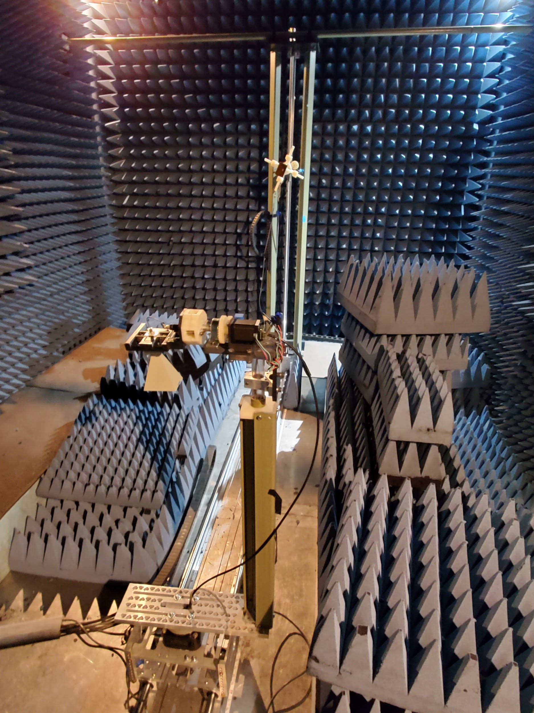

*The Antenna Test Range viewed from the entrance*

*Elevation*

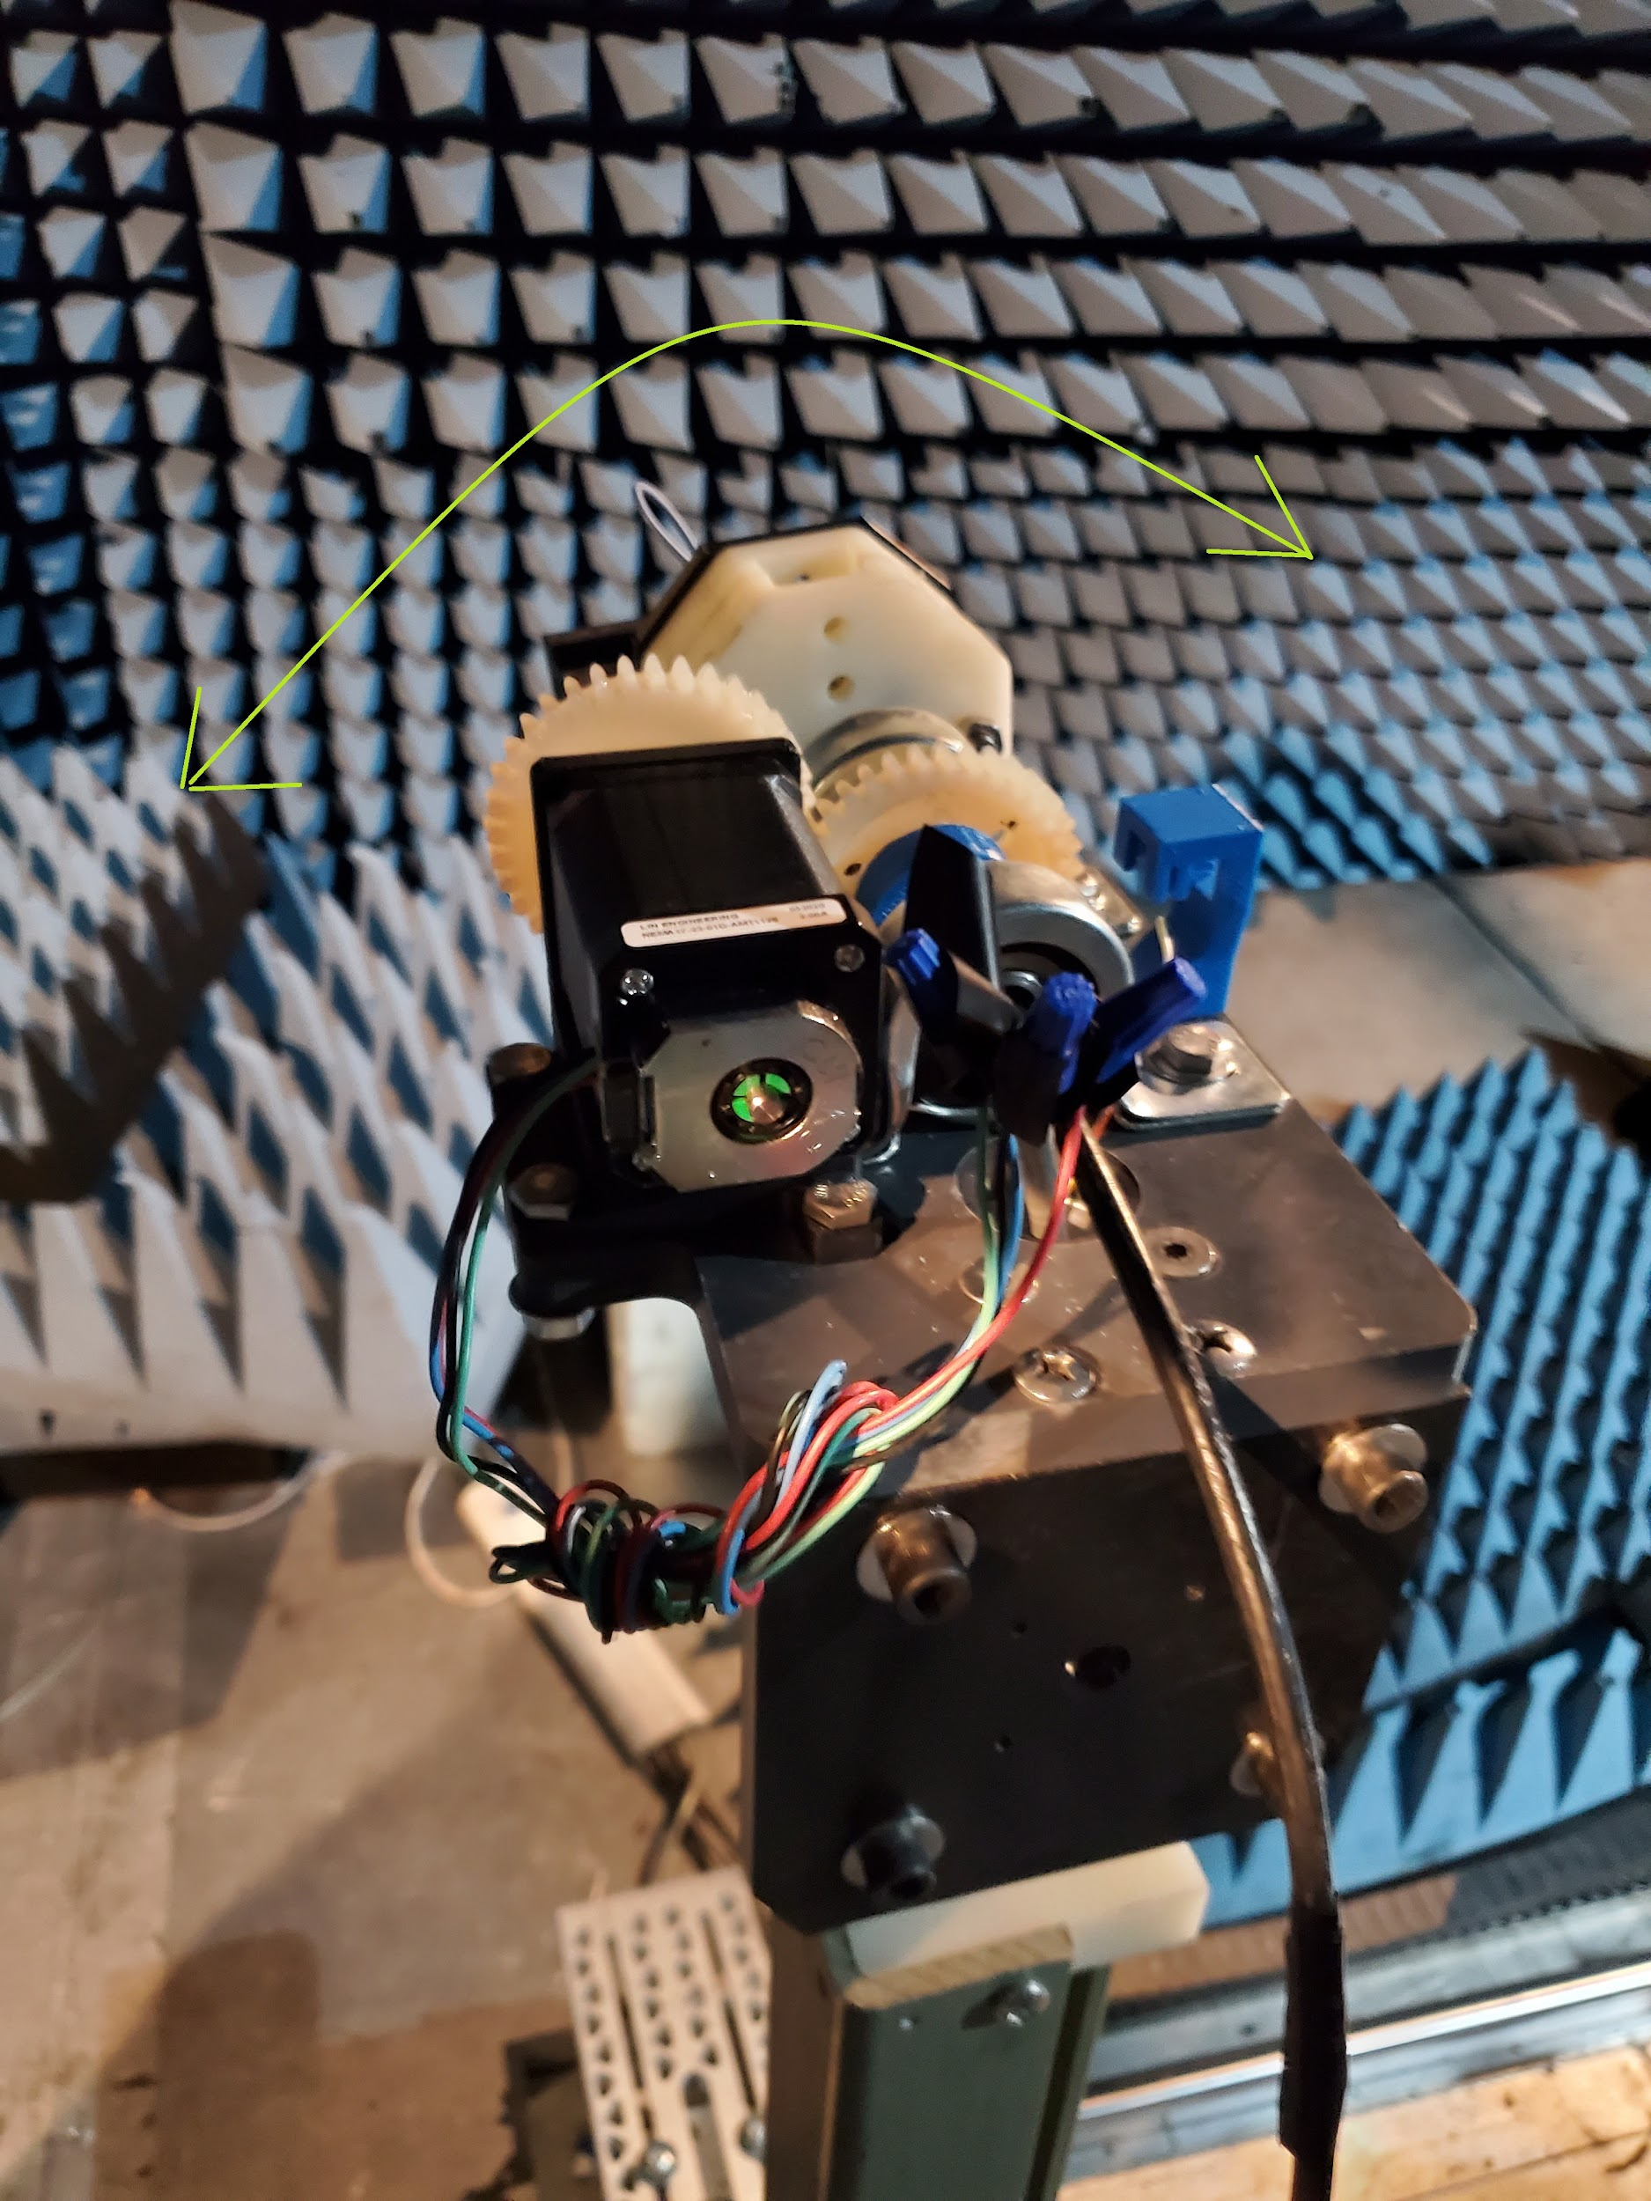

The first axis is the Elevation axis. This is used to change the pitch of the antenna under test relative to the source antenna.

*Azimuthal*

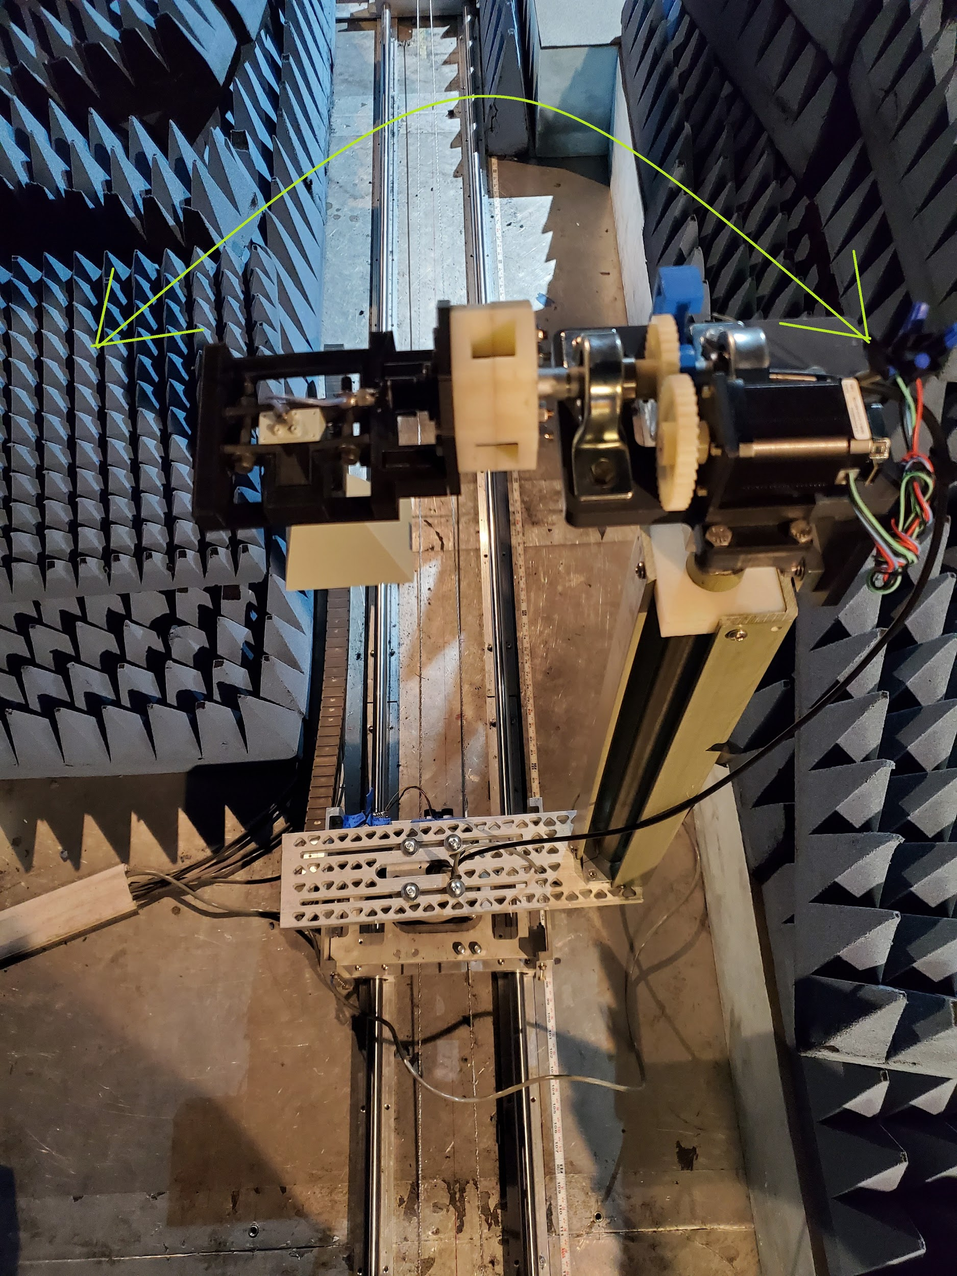

The second axis is the azimuthal axis. This controls the cylindrical rotation of the antenna under test.

*Depth*

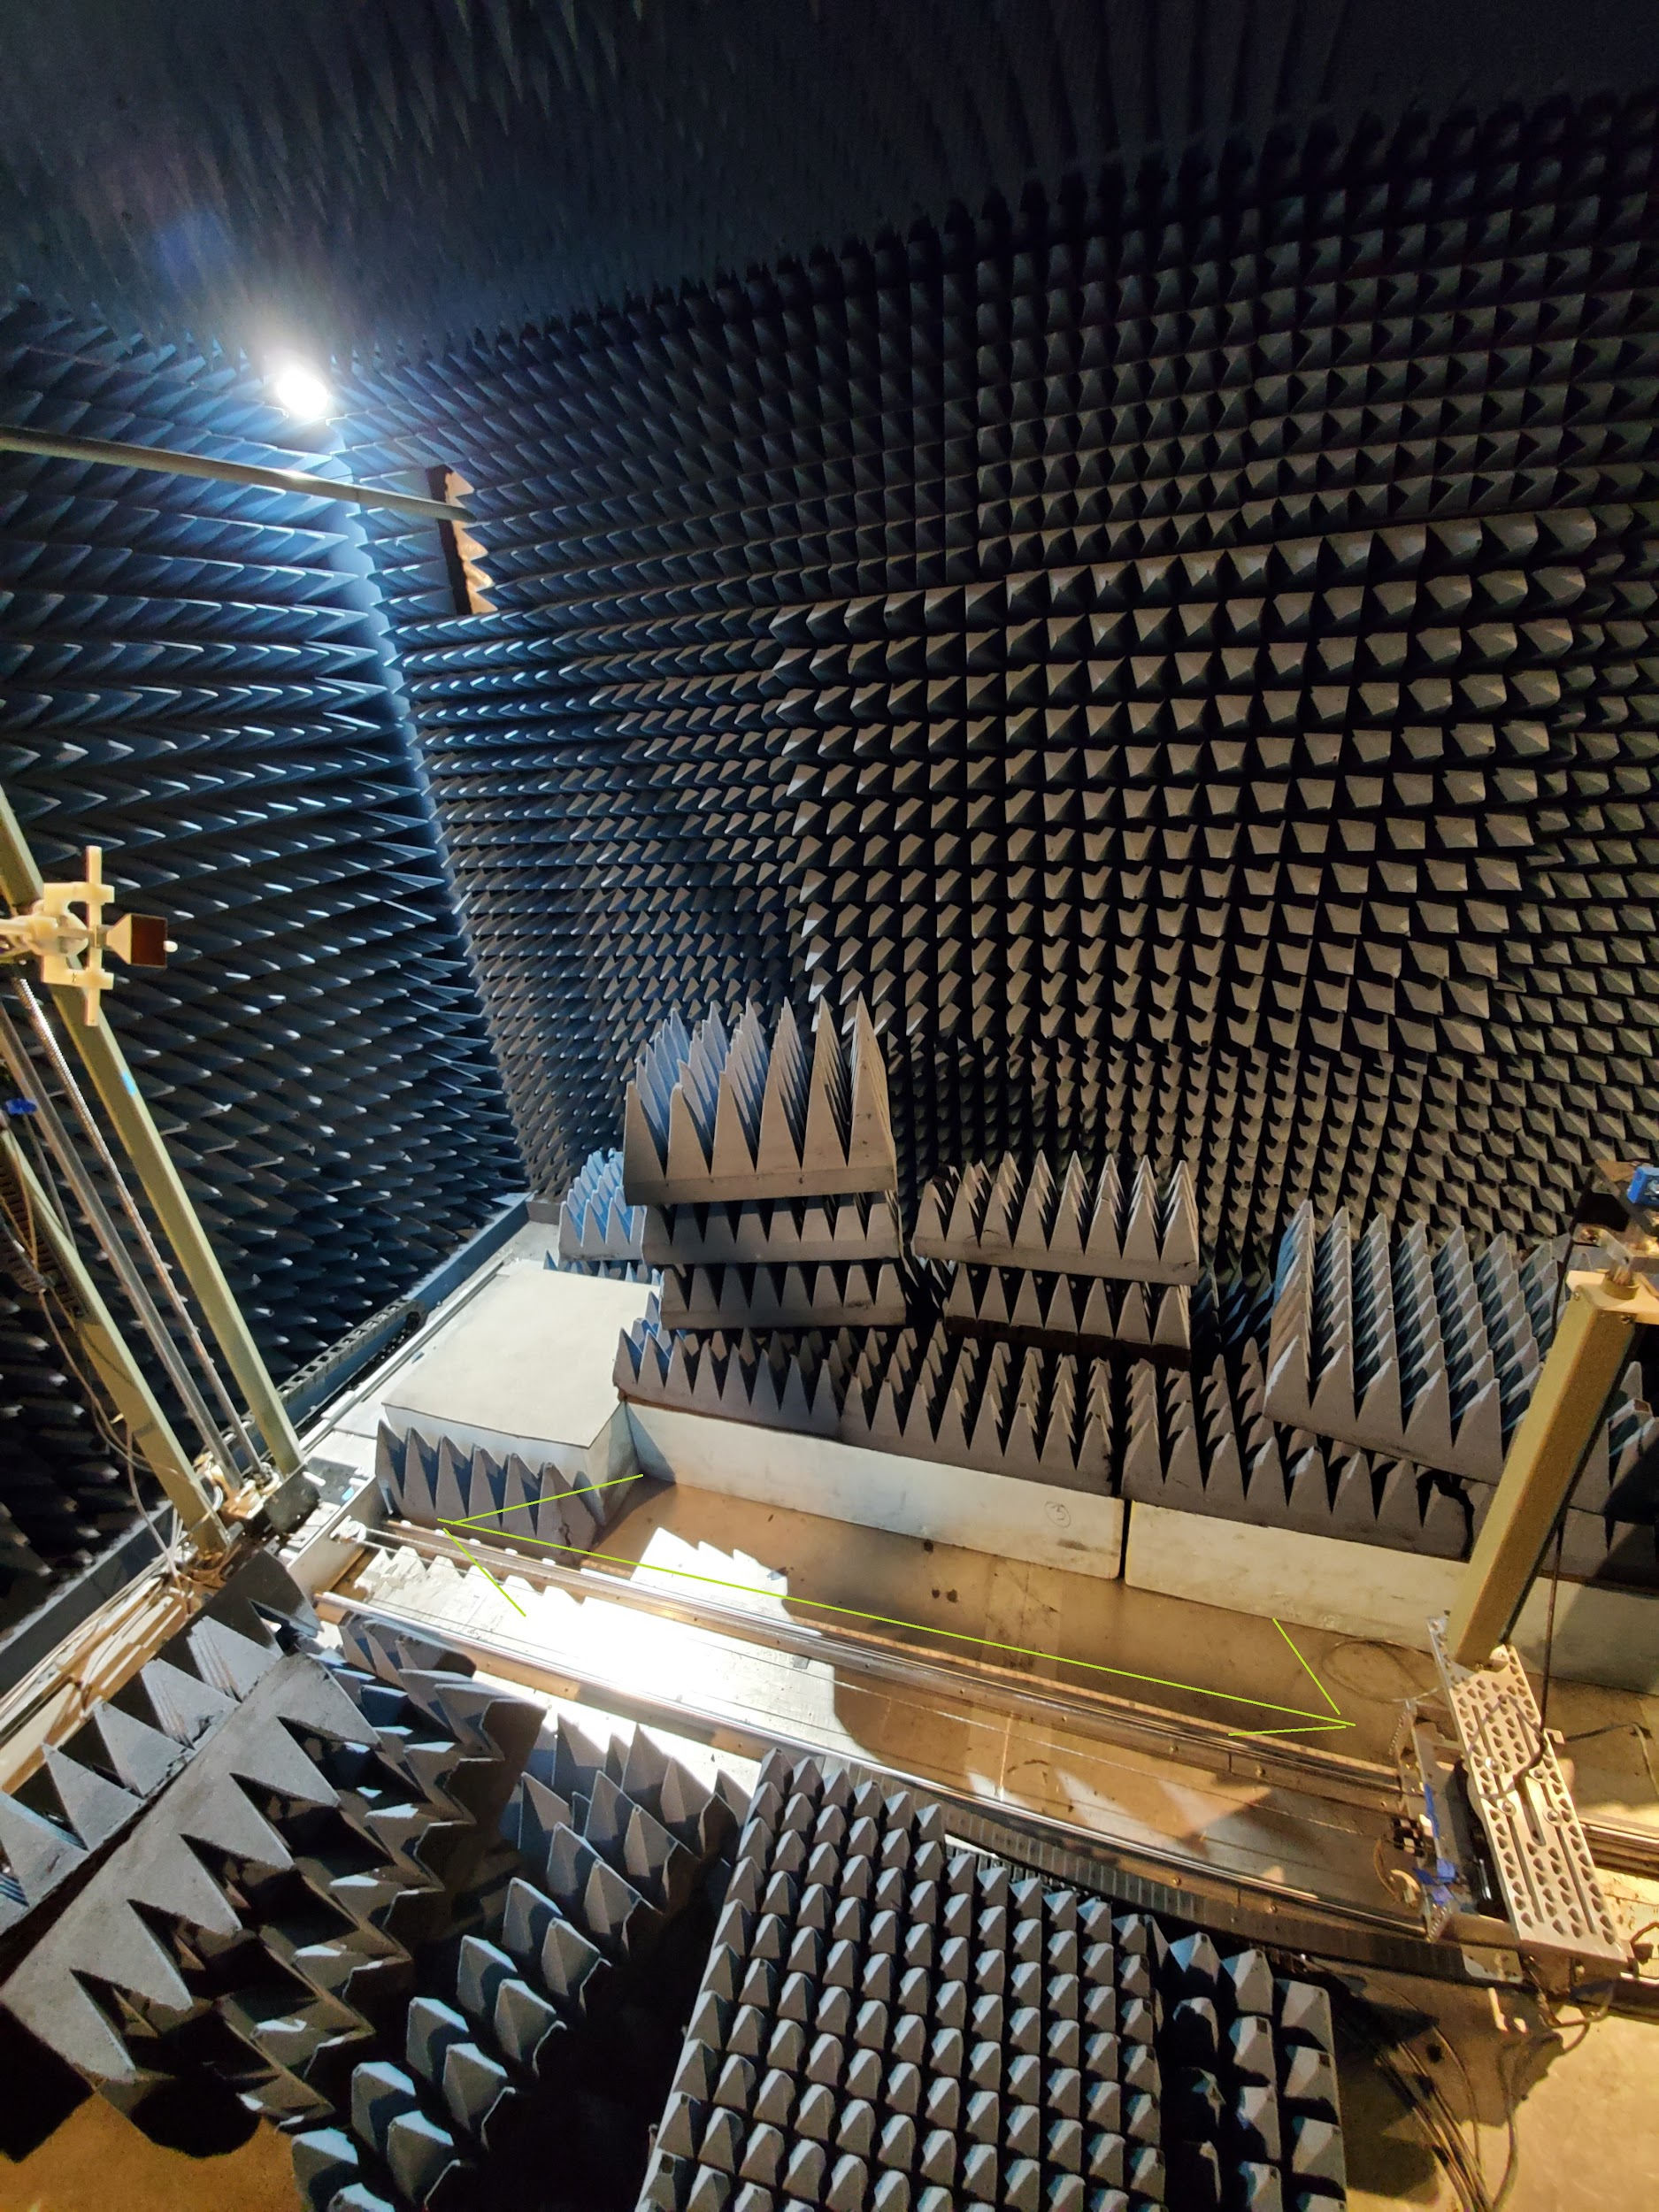

The depth axis controls the distance between the antenna under test and the source antenna

*Horizontal, Vertical, Polar*

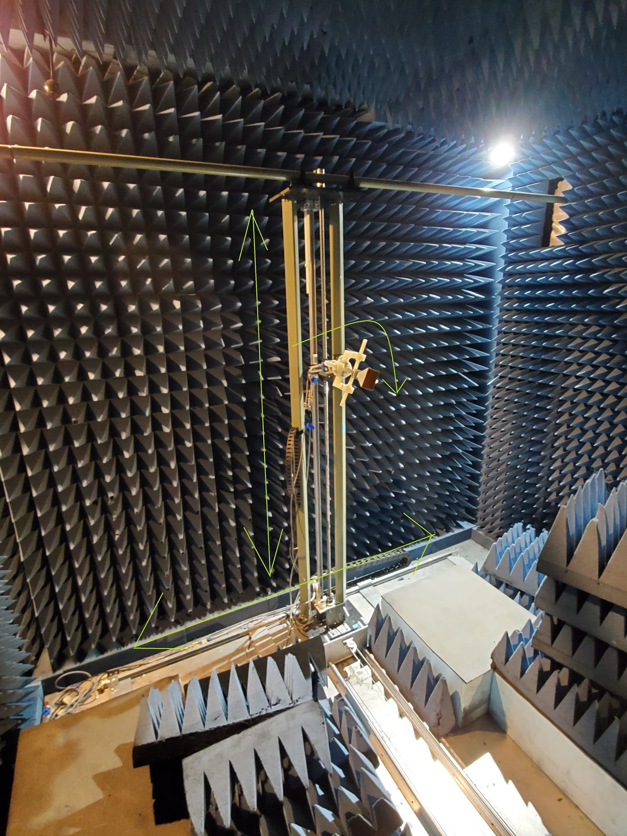

The next axes are the horizontal, vertical and polar axes. Horizontal controls the horizontal movement of the source antenna. Vertical controls the height of the source antenna, and polar controls the rotation of the source antenna.

## *Network Analyzer*

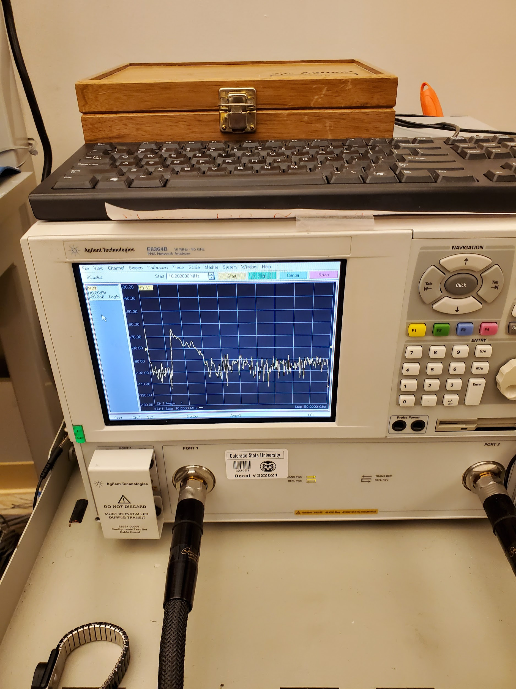

For this project, we use the Agilent E8364B Network Analyzer. This device is designed to send a test signal through a source antenna and measure the response at the Antenna Under Test. For the most part, this device is “plug and play” and little needs to be done other than turning it on and off in standard use.

The Network Analyzer can also be calibrated in order to reduce the impedance effect of the coaxial cables between it and the antennas. However, this is rare and should only be done if data has extreme noise. The image above shows standard noise levels in general operation. There is a guide in the troubleshooting section of this guide that shows how to calibrate the range.

## *Graphical User Interface*

The Graphical User Interface is the software portion of this range. It consists of a downloadable and executable file as well as a MATLAB script. The executable file is designed to perform scans, position motors, and receive and store data. The MATLAB script is designed to convert data from the GUI into 3D material. Setting up the GUI will be discussed in the getting started section, and operating the GUI will be discussed in the software operation section of this guide.

## *Scanning Modes*

Scans are done by setting one or two axes to continuously rotate over a range. Each axis is stepped, meaning it will move a finite amount and then stop briefly. Each one of these “stops” is referred to as a datapoint. At each datapoint, the program will capture the data from the network analyzer and store it for further analysis.

While any two axes can be swept, there are a set of common scanning modes that are used.

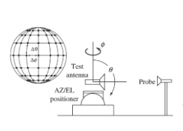

The first, and most common scanning mode is the spherical scan. This is done by rotating the azimuthal axis in a 360 degree motion. At each stop, the elevation axis is then swept from top to bottom. This provides a full spherical characterization of an antenna. This is the most general scan.

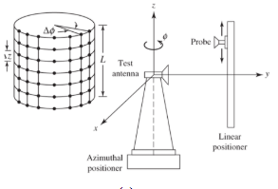

The second most common scan is the cylindrical scan. This is done by rotating the Antenna Under Test on its azimuthal axis, and then at each stop stepping the vertical axis. This is useful for evaluating the near field behavior of an antenna.

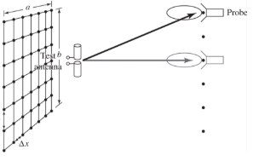

The last common 2D scan is the planar scan. This is done by sweeping the horizontal and vertical axis while keeping the Antenna Under Test still. This is primarily used for evaluating points of high noise within the anechoic chamber.

These three scans form the basis for the majority of operations done in the Antenna Test Range. However, it is possible to monitor the behavior of an antenna by sweeping an axis. For example, though not involved in any of the three scans above, depth scans can be performed by sweeping the depth axis.

Performing these scans will be discussed in the getting started and software sections.

## *Arduino and Motor Controller*

The last system within the Antenna Test Range is the Arduino-Motor Controller system. This consists of an Arduino MEGA and two TB6560 motor drivers. At it’s basic level, the Motor Controllers are stupid, and can’t actually make any commands on their own. The sole purpose is to provide the desired current to the motors. The actual controlling of this is done through the Arduino, which can take commands from the software and convert them into commands that the motor controllers can understand. All of the computations are done through the Arduino. Therefore, no programming is needed on the motor controller itself. In normal use, modification of the Arduino-Controller system is not necessary. However, it may be necessary to change various pin connections for one reason or another. This will be touched upon later in this guide.

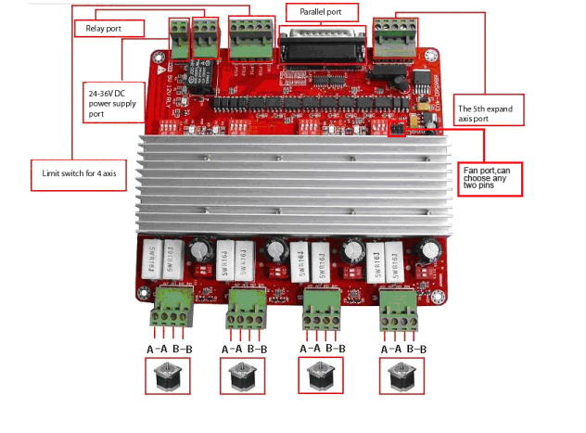

*Motor Controllers*

# **Section III - Software Operation**

The GUI gives the user a medium by which to send commands to the range. Initially, the user can connect to the motor driver and a measuring device in order to begin operation. This will allow the user to send commands to the Arduino in order to position the motors, and therefore the antenna, in different ways as well as perform a series of desired movements. The data from the antenna is received by the PNA and can be sent to the main user interface for data collection. It is important to note that the PNA and the motor controller set are not connected and cannot interact with each other directly. In summary, the primary purpose of the main user interface is to send positional commands, receive measurements, and store data in an interpretable format. Given below are descriptions of the functionality of each component of the GUI, as well as a description of how the MATLAB code is used to generate 3D plots.

## *Graphics User Interface (GUI) Overview*

Once started, the program’s operation can be summarized and terminated using the main window (figure to the left).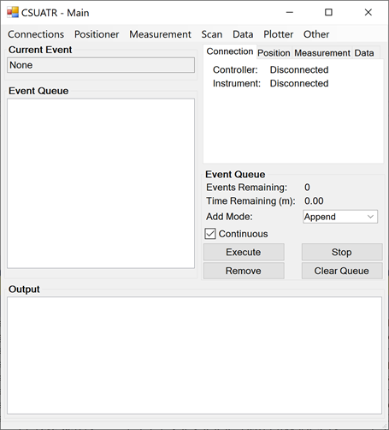

The tabs on the right-side of the window provide updates on connections, motor positioning, measurement characteristics, and data collection.

The sections labeled ‘*Current Event*’, and ‘*Event Queue*’ provide users full control over program operations and commands.

The *‘Output’* section at the bottom provides all necessary verbal feedback for the program.

## *Saving and Loading Settings*

Settings files can be saved and loaded for each window that has modifiable options (except for plotter). This allows users to switch between different setups very quickly without having to re-input information every single time. After starting the program for the first time, some settings files will not be generated until the user opens their associated GUI. After generating a settings file, the settings can be modified by editing its *<settings>.txt* document or by saving the current settings using the *‘Settings’* tab in the top left corner of the screen. If a settings file already exists, it will be automatically loaded when opening its associated GUI if it’s filename and folder name are listed as defaults in the program *meta.txt* file. If the user wishes to load a different file, this can also be done using the Settings tab.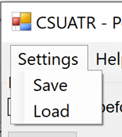

Filenames for settings files typically cannot be changed during the program, rather, the folder which settings are placed can be changed. The settings filenames that are expected by the program can be changed by modifying the *meta.txt* file. These changes will only take effect once restarting the program.

## *Managing Events*

Each operation in this program is considered an event. With the exception of saving and loading settings and using the plotter, program events include the following:

* Connections
  + Connect(address)
  + Disconnect(address)
* Positioner
  + MoveToHome()
  + MoveByAmount(motor, amount)
  + MoveToPosition(motor, position)
  + WaitTime(time)
  + WaitMotor(motor)
  + Calibrate()
* Measurement
  + Measure()
  + SetSParameter(s-param)
  + SetSourcePower(power)
  + SetStartFrequency(freq)
  + SetStopFrequency(freq)
  + SetIFBandwidth(bw)
  + SetSweepPoints(points)
  + SetAveragePoints(points)
* Data
  + SaveData()
  + LoadData()
  + RemoveSelected()
  + RemoveFirst()
  + RemoveLast()
  + ClearDataset()

Events are managed by the main window to ensure that they execute in a chronological, predictable, and non-conflicting way. Events can be added by selecting their corresponding buttons in the other windows. Once selected, they will

1. Execute immediately if:
   1. The event queue is clear
   2. And if there are no other executing events
   3. And if *‘Continuous’* is checked
2. Be added to the event queue if:
   1. There is a current executing event
   2. Or *‘Continuous’* is unchecked

Events can be executed manually one-at-a-time by leaving the *‘Continuous’* unchecked and pressing the *‘Execute’* button.

If an executed event fails after executing, it will be pushed back to the queue and *‘Continuous’* will be set unchecked. This will also send an output notification briefly describing why it failed to execute.

Any executing event can be stopped immediately by pressing *‘Stop’*. Note that this also acts as an emergency stop button should the range enter a dangerous configuration for whatever reason. Any event in the queue can be removed by first selecting it and pressing *‘Remove’*.

All events in the queue can be cleared by pressing ‘*Clear Queue*’.

Events cannot be dragged and dropped once in the queue. They can only be selected and removed.

‘*Add Mode*’ describes how events are added to the queue

1. *‘Append’* adds events at the end of the queue.
2. *‘Insert’* adds events directly before the selected event.
3. *‘Push’* adds events at the front of the queue

There are currently no operations for saving and loading events in the queue

## *Controlling Motor Movement*

In order to operate and reposition motors, an Arduino controller must first be connected using the *‘Connections’* window.

The status of the controller can be viewed in the main window’s ‘*Connection*’ tab.

The Arduino must have the CSUATR_Arduino.ino code uploaded in order to operate properly. This only needs to be done once upon first use, unless modifications are made.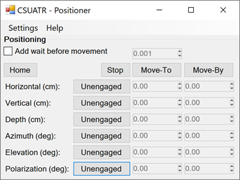

Once connected, the *‘Positioner’* tab provides tools to move or stop motors and add wait times before each movement if desired.

To move the desired motors, press the ‘*Unengaged/Engaged*’ button to toggle the motors that need to be moved before pressing ‘*Move-To’* or ‘*Move-By*’

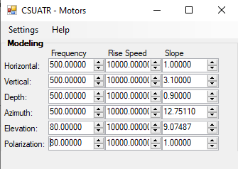

‘*Move-To*’ moves to absolute position

‘*Move-By*’ moves by absolute amount

*‘Home’* is used to set the range to adopt a new default or *home* position. This is useful if for any reason any axis is at an odd position according to its recorded value in software, when in reality the axis is in a zeroed position.

‘*Stop’* will stop all active motors, update the new position, and return a failed command in the event queue.

The ‘*Motors’* window allows users to modify the model coefficients for the motors. This allows the program to predict motor positions without the use of encoders.

To calibrate, the easiest route is modifying the *‘slope’* parameter until a positioning command produces a distance of satisfying accuracy.

The model follows the following structure:

* Frequency - Coefficient that is used to guide speed of motor directly
* Rise Speed - Models 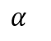 in x(t)
* Slope - Models 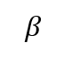 in x(t) ɑα
* Model:

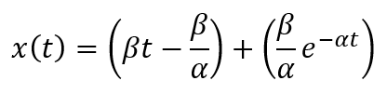

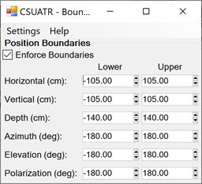

The ‘*Boundaries’* window allows users to modify and enforce motor virtual boundaries. These will restrict a motor’s movement if it calculates that its expected position will reside outside of the boundaries.

These can be turned on or off with ‘*Enforce Boundaries*’ checkbox

Changes to the fields in this window and the ‘*Motors*’ window will take effect for any event executed after they are changed. (They will not modify concurrent movements)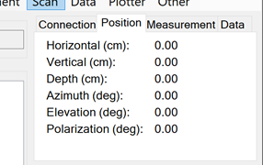

Real-time position can be observed from the main window in the '*Position*’ tab

## *Interfacing with the Network Analyzer*

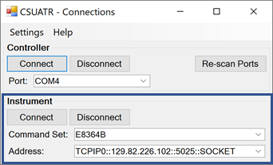

Before a connection to the PNA can be established, the user must first be connected to CSU’s public WiFi through their EiD.

Connect to the PNA through the ‘*Connections*’ window.

Before connecting to the instrument, 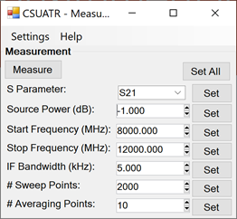

IOLibSuite (in the software folder) must

be downloaded and installed. Select all default options when installing.

‘*Command Set’* specifies an instrument. Use the E8364B.

‘*Address’* specifies a communication line for the instrument (found using command *‘ipconfig’* in the command terminal on the PNA). Unless changed, the address should be the one as shown above. Addresses can be saved in their own *addresses.txt* file.

Go to the *‘Measurement’* window to modify instrument properties and take measurements.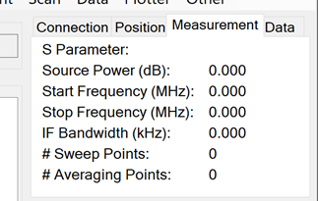

*‘Measure’* initiates measurement.

‘*Set’* for any field commands that change once pressed.

‘*Set All’* sets all fields.

Current measurement attributes can be viewed in the main window ‘*Measurement’* tab.

## *Generating Scans*

Using the ‘*Scan*’ window, users can add all events to the queue that follow a scan structure.

Similar to ‘*Positioner*’, motors can be ‘*Locked’* and ‘*Unlocked’* indicating that they add a dimension to the scan.

For ‘*Scan Type’*

* Single indicates one motor (takes first ‘*Unlocked’* motor on list)
* Double indicates two motors (takes first two ‘*Unlocked’* motors on list)

Users also have the option to save the measurement data after every single measurement to ensure that data is not lost in the event of disruption.

‘*Lower Limit*’ indicates lowest position for that axis to use

‘*Upper Limit*’ indicates highest position for that axis to use

‘*Resolution*’ indicates the maximum difference between measured values (the lower the resolution value, the more points, the longer the scan takes)

‘*Add Events’* will add all necessary events to the queue

By default, data is saved after every measurement. Data is updated in real time, and can be viewed in its raw form in the *‘Data’* tab, or in a 2D graphical representation in the *‘Plotter’* tab.

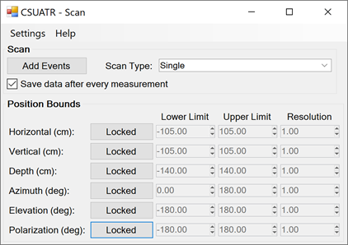

Once all events are added to the queue, the queue should look similar to below.

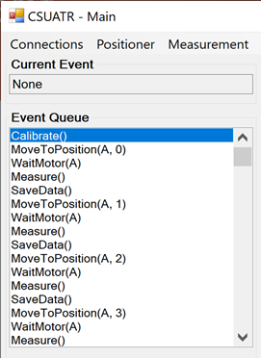

Note: ‘*Calibrate’* currently only zeros out the motors. Hence, it is recommended that motors are started at their “zeroed” position before executing the scan. As mentioned earlier, this is doing by selecting ‘Home’ in the ‘Positioner’ tab.

## *Managing Data*

For any measurement that is collected, the data points can be viewed in the ‘*Data’* window. Here, users can load, save, or edit data. Additionally, the current number of data points and ‘*Saved Status*’ can be viewed in the main window’s ‘*Data*’ tab.

A “point” is composed of:

1. *ID* - Unique number that distinguishes the point from other data points in the set.
2. *S##* - S Parameter used for measurement
3. *Power* - Power used for measurement
4. *Horizontal* - Position of antenna during measurement
5. *Vertical* - Position of antenna during measurement
6. *Depth* - Position of antenna during measurement
7. *Azimuth* - Position of antenna during measurement
8. *Elevation* - Position of antenna during measurement
9. *Polarization* - Position of antenna during measurement

There are currently no options to drag and drop data points, however, poor data points can be removed using:

* ‘*Remove Selected*’ removes selected point (will not remove any if none are selected)
* ‘*Remove First*’ removes first point in dataset
* ‘*Remove Last’* removes last point in dataset
* ‘*Clear Dataset’* removes all data points

Poor data points may on occasion appear as a sudden spike, a carbon copy of a previous data point, a data point with all values zeroed out, etc...

‘*Query Warning*’ changes whether users are warned before removing data points each time. This warning, however, will always come up for clearing the dataset.

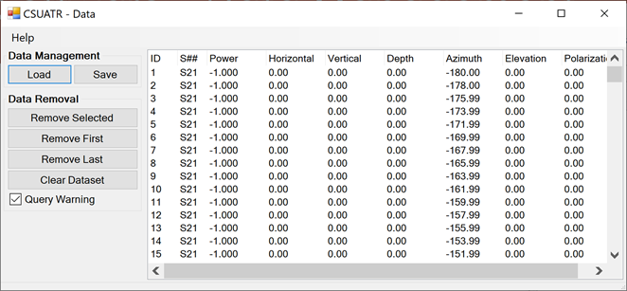

## *Plotting Data With GUI*

Plotting data with the built in plotter is useful in running quick scans of a single axis, as the time commitment to run such scans is a fraction of the time required to run multi-axis scans.

The ‘*Plotter*’ allows users to plot their current dataset using a variety of plot types and filters.

* **Plot Type - Method for presenting data**
  + Line
  + Scatter
* **Y Axis (Line Plot) - Type of data provided that ‘Line’ is selected**
  + Amplitude
  + Magnitude
  + Phase
  + Real
  + Imaginary
* **Axes (Scatter Plot) - Type of data provided ‘Scatter’ is selected**
  + Magnitude/Phase
  + Real/Imaginary
* **X Axis/Variable - Attribute that filters what data is presented**
  + Frequency
  + Source Power
  + Horizontal
  + Vertical
  + Depth
  + Azimuth
  + Elevation

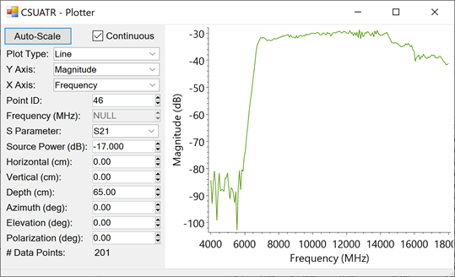

For each variable, the user can select its value in order to present the correct data. Take note, when first starting the plotter, all values will default to ‘Null’. These will remain until a ‘Point ID’ is selected which will autofill all of the other yields (assuming that the ‘S parameter’ is set accordingly). Point ID is only available when ‘Frequency’ is selected as the variable (default setting), hence it is recommended to select a Point ID before switching the variable e.g. azimuth or horizontal. Once switching to the new variable, the frequency will still remain ‘Null’ so changes to it should provide all details needed to filter and present data.

The plot to the right of the option panel is also interactive:

* To zoom in:
  + Scroll forward
  + Right click + Ctrl + drag (box zoom)
* To zoom out:
  + Scroll backward
* To move the current view:
  + Right click + drag
* To get info on particular point:
  + Left click
* To move screen back to original position:
  + Press ‘Auto-Scale’ in top left corner
* To have the plot automatically update with each new data point:
  + Check ‘Continuous’

The program will allow up to four separate resizable plotting windows at the same time. Add another window by clicking the ‘Plotter’ menu item in the main window. If there are already four windows, clicking ‘Plotter’ will resurface the last plotting window.

There may occasionally be some quirks with the plotting software, and below are some tips for ease of use:

* Instead of typing inside the box, try selecting the box and then using your arrow keys to scrub through data.
* If you cannot see your data, make sure you’re viewing with *‘S Parameter’* set to *‘S21’*.

## *Plotting Data With MATLAB*

For scans of type ‘Double’, a.k.a, multi-axis scans, then it is useful to represent that data in 3 dimensions using MATLAB. Among the several MATLAB scripts provided, the most straightforward to use is ‘CSUATR_v2_Data_Interpretation.m’, and shown below is how it is used.

After a double-axis scan is complete, and the data is saved to a file, place the file in a known location so you can give its location to the script.

Open the script, and take note of the first few lines which give assignments to dataPath and dataFile. Type in the path to the collected data and the name of the file to each variable respectively. For example:

dataPath = "C:\Users\Jason\Documents\SeniorDesign\csuatr\Matlab Code\Data\";

dataFile = "11_18_2020_Elevation_Azimuth.txt";

**--- Don’t forget the semicolon! ---**

Next label xAxis and yAxis with the two axes used during the scan. These are written as:

* ‘Polarization’
* ‘Vertical’
* ‘Horizontal’
* ‘Depth’
* ‘Azimuth’
* ‘Elevation’

Then, for the data to be properly formatted to the 3D space, the number of data points collected on each pass of the chosen x-Axis must be given to xAxisWidth

For example:

* The collected data used the azimuth axis
* The azimuth axis was selected as the xAxis
* The azimuth axis had a lower limit of -60°, upper limit of 60°, resolution of 3°
* Therefore, (60 - (-60))/3 + 1= 120/3 + 1 = 41 data points were collected each pass
* Therefore, xAxisWidth = 41

**\*\*\* NOTE \*\*\***

It was found while generating a 3D plot for a very large data set, the above method to calculate xAxisWidth did not work, and the plot came out nice only calculation was made for the y-Axis (rounded up). It turned out that not all data was plotted, and this also seemed to have the effect of flipping the axes. Be wary of this, and perhaps stick to bounds which are evenly divisible by the number of measurements you’re doing… (ex: Use -90 to +90 with resolution of 3°, instead of -80 to +80 with resolution of 3°)

The last variable, frequencyIndex, is used to select which frequency to graph. For example, a frequency spectrum spanning 10MHz to 50GHz generates a list of 200 linearly spaced frequencies (201 when counting for the 10MHz) . For example, a frequency index of 33 gives 8.008GHz, which, if inside the frequency band of the antenna used will provide a graph with a high signal to noise ratio (SNR) for when the SA and the AUT are pointed towards each other.

From here you can run the script, **however**, it is possible for the script to crash if it comes across a bad data point. If this happens, simply open the raw data file, and jump to the troublesome data using ‘Ctrl+f’. For example, if I can tell that data point 1842 is bad, I’ll search for “1842 S21” and replace its associated data with the data that either precedes it or comes after it (doesn’t matter, but that data point needs to exist with complete data fields). What usually happens is that a datapoint for whatever reason did not have all its data saved, and most of the data looks like it got zeroed out. The format of the data in the text file is as follows, with each line labeled by a number.

1. Data point number | S parameter | Power | Position information etc…
2. List of frequencies used…
3. …
4. …
5. Recorded real component of signal corresponding to above frequency…
6. …
7. …
8. Recorded imaginary component of signal corresponding to above frequency…
9. …
10. …

If a data point for whatever reason does not follow the above format, then it is a bad datapoint, and its data needs to be replaced with that of a neighbor.

# **Section IV - Network Analyzer Operation**

The network analyzer used on this range is an Agilent E8346B. Note that Agilent has been acquired by Keysight Technologies, and therefore all documentation can be found through them. At its most basic level, little needs to be done with day to day operation of the Performance Network Analyzer (PNA) other than simply turning it on.

The first thing to do is ground yourself when using the network analyzer. This can be done by wearing the anti-static wristband found next to the analyzer. It is critical that this is used at all times when touching the PNA, keyboard, mouse, or coaxial cables. The PNA is extremely sensitive to static electricity, and failure to ensure proper grounding may result in major damage to the PNA.

The next step is to simply turn on the power. This is done by pressing the yellow power button in the lower left corner. When pressed, it should change to green. The bootup process takes around five minutes or so and when finished, the screen will be filled by the PNA’s measuring program, as seen below.

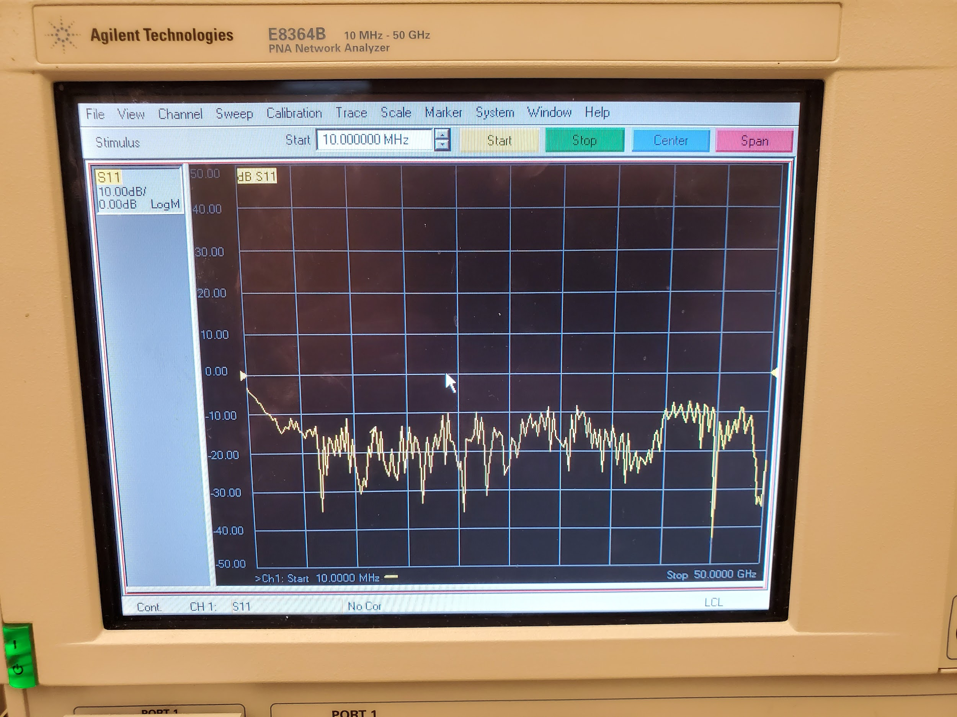

A few simple adjustments may be desired. The first is to set the displayed measurement. By default, the PNA displays S11. This S-parameter corresponds to the response of port 1 of the signal from port 1. Essentially, just noise. In most cases, S12 or S21 should be selected, this can be done by going to Trace -> Measure -> S12/S21. S12 and S21 measure the response at one port due to the signal from the other, essentially the response of the antenna under test from the source antenna. Note that due to reciprocity, S12 and S21 will produce the same signal, albeit inverted, and therefore either can be used to judge the behavior of the antenna with no difference.

In some cases, calibrating the network analyzer may be desirable. However, in most situations the default calibration will be more than serviceable. Thankfully, the PNA has a built in calibration wizard that can be accessed by going to Calibration -> Calibration Wizard. The wizard will walk the user through the steps required to calibrate the PNA. The measurement devices used to calibrate the range can be found in the wooden case on top of the PNA. There will be two devices, one for female coaxial cables and one for males. Each device has three ports, open (O), short (S), and load (L).

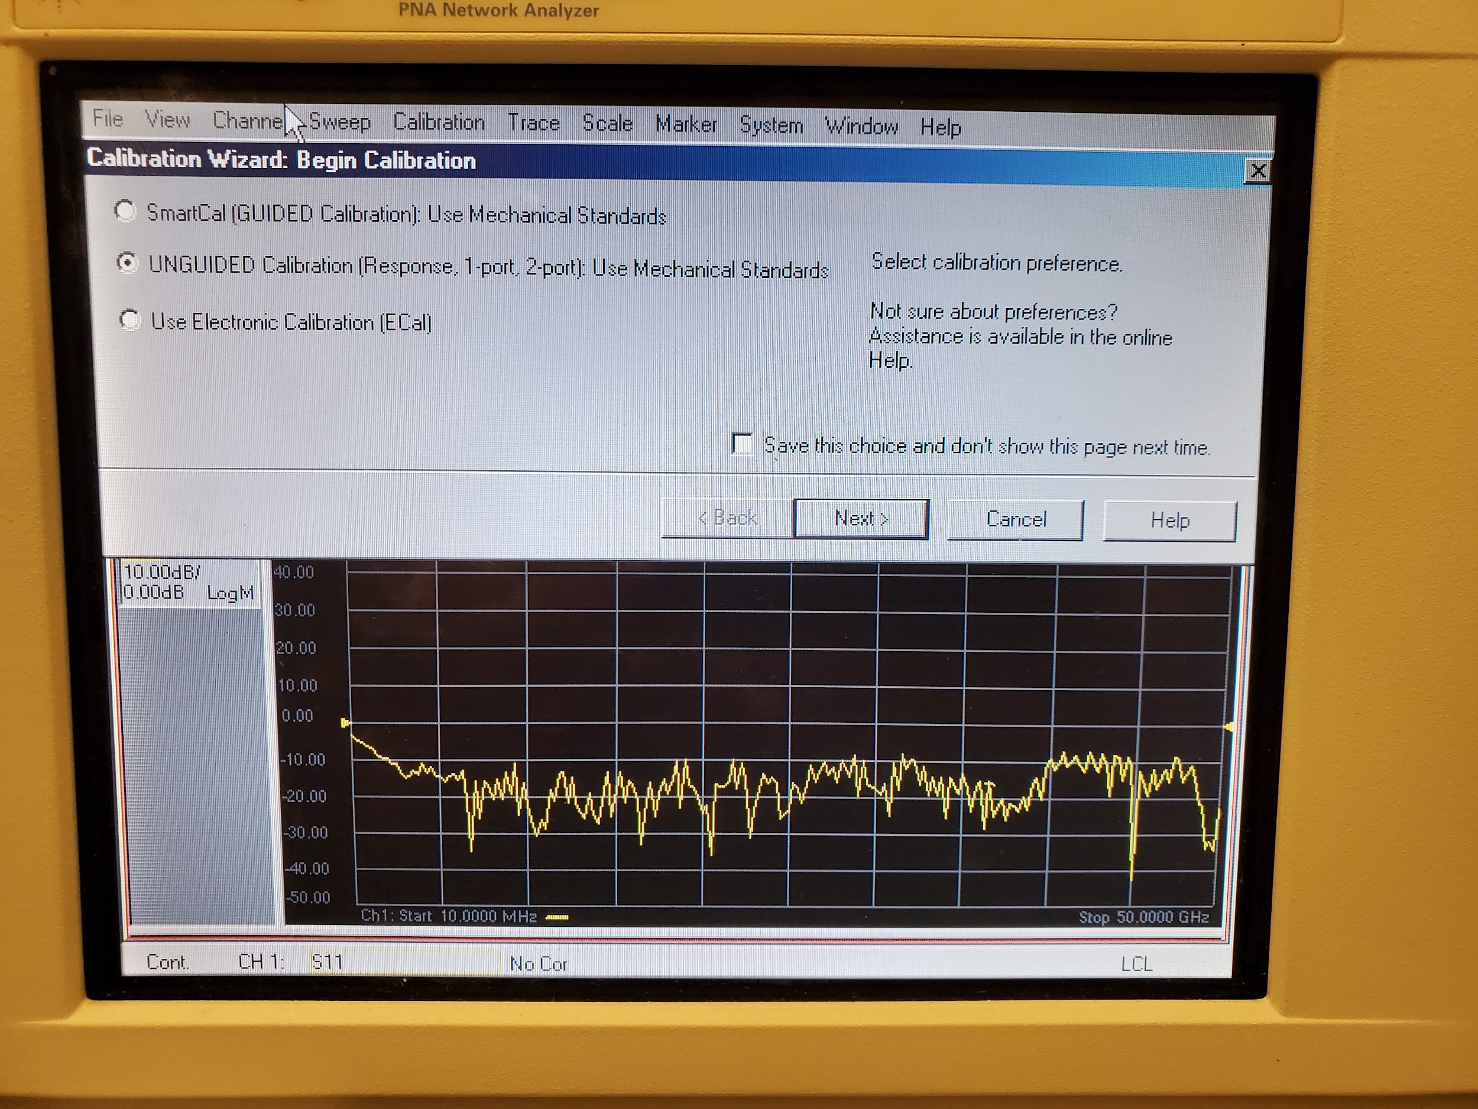

First, begin by disconnecting any antennas from the range and use the depth motor to bring the antenna-under-test mount to within 2 or 3 feet of the source antenna. Next, simply follow the steps on the wizard on what to connect. For example, the wizard will prompt the user to connect port 1 to the ‘open’ port on the calibration device. Simply attach the device to the coaxial cable, and run the prompted ‘scan’ from the wizard. You will repeat this process for each of the coaxial cables as well as run a through (both cables connected to each other) and put (both cabled detached from anything) measurement as well. This will result in a total of 8 measurements. At the end of the wizard the new calibration can be saved. Note that each time the range PNA is booted up you will have to manually load the calibration from the file -> load menu.

The network analyzer runs on Windows XP and is (rarely) susceptible to window’s various bugs. In the event of rare errors such as program crashes or freezes, the task manager can be accessed if necessary. To turn off the network analyzer at the end of the day, simply press the windows key and shut off the network analyzer like you would any windows computer. DO NOT simply press the power button, as the sudden discharge can result in damage to the PNA’s measurement instruments.

# **Section V - Motor Controller and Arduino Guide**

Although in normal use modifying the pin assignments on the motor controller are not necessary, some circumstances may arise that require a remapping for one reason or another. The first thing to look at is the actual layout of the motor controller



Shown on the bottom of the image are the actual ports connecting to the motors. It can be seen that there are four four-phase ports. The upper ports on the image have the ports for the power supply and the parallel port. The fifth axis ports, limit switches, and relay ports are not used. The parallel port is used for connecting the Arduino to the motor controller itself. The pin list is as follows:

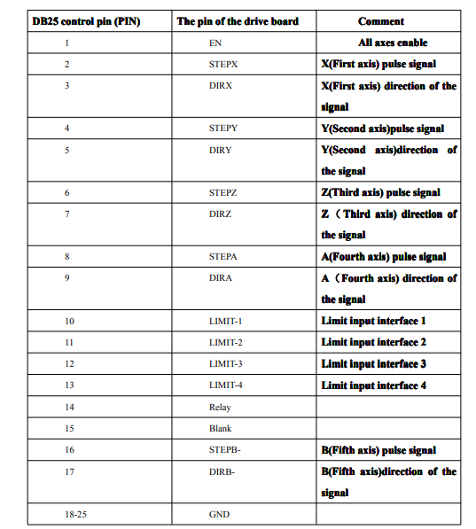

Note that each pin’s wire is already labeled. On the motor controller you will see that each port is labeled A through D. On this chart, A corresponds to “First axis” and D corresponds to “Fourth axis.”

Taking a look at the provided Arduino code (explaining in the software section) will detail the actual assignments of the Arduino pins themselves.

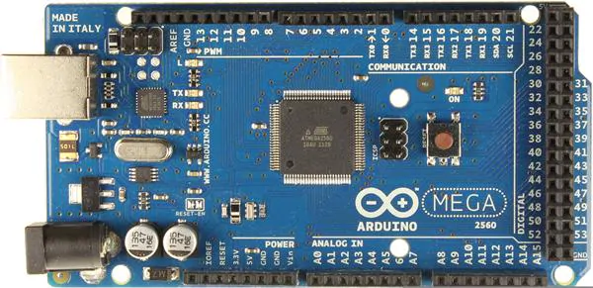

const int PIN_ENABLE_MOTORS = 50;

// Direction

const int PIN_DIR_MOTOR_H = 37;

const int PIN_DIR_MOTOR_V = 39;

const int PIN_DIR_MOTOR_D = 41;

const int PIN_DIR_MOTOR_A = 43;

const int PIN_DIR_MOTOR_E = 45;

const int PIN_DIR_MOTOR_P = 35;

// Step

const int PIN_STEP_MOTOR_H = 3;

const int PIN_STEP_MOTOR_V = 2;

const int PIN_STEP_MOTOR_D = 6;

const int PIN_STEP_MOTOR_A = 7;

const int PIN_STEP_MOTOR_E = 10;

const int PIN_STEP_MOTOR_P = 9;

Note that each motor must have a corresponding “direction” and “step” pin, as well as master “enable” and GND pins.

Connecting pins from the microcontroller to the motor controller is relatively simple. For example, we’ll look at hooking the “depth” axis motor up. From the code above, we can see that the depth motor “D” has its direction assigned to pin 41 and its step assigned to pin 6 (note that these are the pins on the Arduino, NOT the motor controller).

Let’s say that we want to hook our depth motor up to the first axis on the driver. We simply plug the cable labeled “Depth” into the axis labeled “A” on the motor controller. Next, we’ll see that the wires controlling the first axis are 2 for “Step” and 3 for “Direction.” (Note that these are the wires coming out of the parallel port cable connected to the motor controller). From here we simply take wire 2 and connect it to pin 6 on the Arduino, and take wire 3 and connect it to pin 41 on the Arduino. Make sure that at least one GND wire is connected to the GND on the Arduino and that the master enable wire (wire 1) is connected to pin 50 on the Arduino. After these steps, the depth motor should be ready to go.

If desired, pins can be reassigned in the Arduino code, though this is not necessary.

## 

# **Section VI - Common Errors and Troubleshooting**

## *PNA*

**1.1 - Failure to connect to PNA**

* Check that you are connected to the school’s WiFi with your EiD.
* Check that the socket you’re connecting to is that of the PNA.

i.e. Command set: E8364B

Address: TCPIP0::129.82.226.102::5025::SOCKET

* Ensure that the IOLibSuite was downloaded and installed. This file, IOLibSuite_18_1_25310.exe, should be located in the “CSUATR Program Release” folder in the google drive.

**1.2 - Errors on display when performing scan**

* It’s likely that you will see errors appear on the PNA while running a scan. These errors are non-consequential. They relate to the PNA setup performed by the CSUATRv2 program, but the data received by the program is not affected and you can proceed as normal.
* This is the result of a quick fix when it was discovered that the setup code caused poorly recorded frequency responses.
* This fix was made on line 96 of E8364B.cs by commenting out a line of code. (Either that line or line 81, can’t quite remember)
  + Unapplying this fix and pursuing a more thorough investigation could be a task to be performed, though not very high priority since it’s not crucial to the function of the range.

**1.3 - Frequency response with unusual spikes**

* Odd frequency responses can come from a multitude of sources.
  + Improperly mated coaxial cables.
  + Kinks in the line (and other damage to the wires)
  + Improperly calibrated PNA.
* Unapplying the quick fix that was detailed in the previous section (1.2), it is possible that you will see unusual spikes in the plotter of the GUI. The cause of this is unknown, and we didn’t have the time to go too deep into it, hence the quick fix. Refer to 1.2 for more details.

## *GUI*

**2.1 - Cannot get plot to show**

* The plotting software is not perfect, and sometimes behaves a little ornery. Try the following procedure:
  + Select S parameter S21. This should show the frequency response
  + If you want to see how the response responds to an axis that was used during the scan, select that from the X-axis drop down menu (example - vertical).
  + Click inside the box for frequency that likely reads NULL
  + Using the up/down arrow keys on your keyboard, cycle through the sample frequencies until the desired frequency is visible.

**2.2 - Changed settings (motors, boundaries, etc…) are not taking**

* Occasionally the save functions available do not actually save. Since everything is located in .txt files, it is easy to manually enter the changes (file found in CSUATRv2/bin/debug/settings if working from the source code, or simply in /settings if using the executable)

**2.3 - Errors when building project in Visual Studio**

*References that cannot be found:*

* In the "References" tab of the solution explorer, go to "Add Reference" and then at the bottom go to "Browse". From here you can select all the .dll files that should be found in the directory that has CSUATR.sln .

*Certificate can't be found/out of date:*

* Open your .proj file in a text editor, and delete the following lines:

<PropertyGroup>

<ManifestCertificateThumbprint>...........</ManifestCertificateThumbprint>

</PropertyGroup>

<PropertyGroup>

<ManifestKeyFile>XXXXXXXXX.pfx</ManifestKeyFile>

</PropertyGroup>

<PropertyGroup>

<GenerateManifests>true</GenerateManifests>

</PropertyGroup>

<PropertyGroup>

<SignManifests>false</SignManifests>

</PropertyGroup>

## *Arduino / Controller*

**3.1 - Audible ‘pop’ and/or smell of smoke while using range**

* If while running the range a crack or pop sound could be heard, or if at any point one can smell something burning, power should immediately be cut to the controllers. It is very likely that one of the driver ICs on the back of one of the controllers blew.
* The controller should be removed from the case, and the faulty IC removed and possibly replaced if the root source of the failure is identified. At the time of writing this manual, there are several replacement ICs located on the upper shelf of the ATR workbench. Also located on the upper shelf are two spare controllers if it is deemed necessary to try all new controllers.

**3.2 - Arduino cabling**

* While not so much an error, the cabling on the arduino can be the source of many issues if the axes that are in use are not properly plugged in. Precaution should be taken to ensure that the axes under use are actually plugged in, and none of the other wires are shorting each other.

# **Section VII - Future Tasks**

(In suggested order of completion)

1. **Fix Horizontal Axis**
   1. The horizontal axis is currently not in operation. The original motor was 6-phase, but we could not get our hands on one before the semester ended, so we opted for a 4-phase motor. We did not have a chance to get the axis working with this motor before we left, so this should be the first focus.
   2. There is also a concern with the rotary stage. Apparently previous teams had trouble with it, so it may be getting jammed during movement and causing motors to cook themselves.
2. **Redo Arduino Wiring**
   1. Over the years, the cabling on the Arduino has become a bit of a mess. After it is determined that all axes are fully operational, work should be done to finalize all the connections on the arduino to whatever extent is deemed necessary. At the very least, all axes should be connected at the same time without risk of one accidentally becoming unplugged.
3. **MATLAB Modeling**
   1. Time permitting, it would be ideal to have some better MATLAB modeling scripts to better visualize the data the range can provide.
4. **Test Other Antennas**
   1. With the range more or less fully operational (at least in the near field), it would be interesting to see what results come about from testing different types of antennas. This would certainly provide a lot of interesting graphics to present with.
5. **Near-field to Far-field**
   1. This will no doubt be a big undertaking that has up to this point been continuously put off for one reason or another. We have some NTFF documents to peruse in the Documentation folder, but aside from that, NTFF is a blank book.
6. **LIDAR Positioning (or equivalent)**
   1. The range more or less guesses where it is based on the commands it sends to the controller. The quality of this guess is determined by the accuracy of the motor calibration. What can happen, however, is that the motor is commanded to move, and that command is recorded as is the amount moved, but that does not mean that the motor actually moved; only that we told it to move, and that is what’s tracked.
   2. For the safety of the range and the accuracy of its measurements, it would be ideal to have some measuring system in place to determine the exact position of each of the axes.
7. **Calibrate PNA for Range**
   1. Calibrating the PNA for the range is not super critical, as we were able to get plenty of good quality scans without going through the calibration procedure. Even when we did, the calibration process often resulted in some wacky output, so users can look into calibrating the PNA for the range if they so choose, but I would not recommend bothering unless there’s a good reason. Currently, there are far more pressing concerns.